**Ideation phase**

**Brainstorm & Idea Prioritization**

|  |  |
| --- | --- |
| **Date** | 30 September 2022 |
| **Team Id** | PNT2022TMID46979 |
| **Project Name** | PROJECT-5841-1658817731 |
| **Maximum Marks** | 4 Marks |

**Reference:**

https://app.mural.co/t/dharunbabu0107/m/dharunbabu0107/1665902198021/a3b85350bec9c5b91433213a9cda791c08cdc95a?sender=u3ef940e708f93ede574f1024

**Step-1: Team Gathering, Collaboration and Select the Problem Statement**

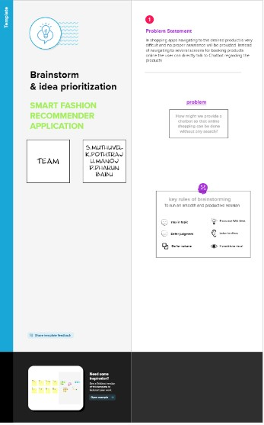

**Step-2: Brainstorm, Idea Listing and Grouping**

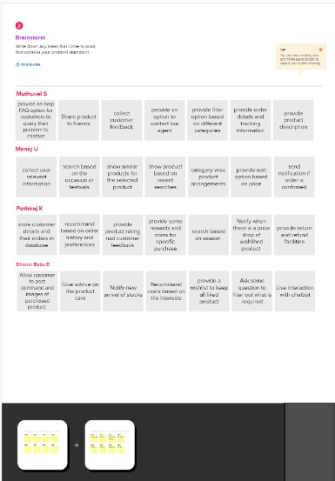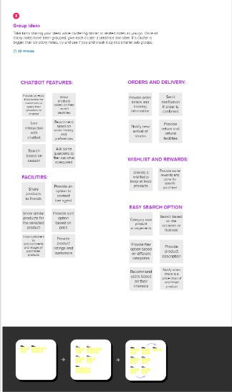

**Step-3: Idea Prioritization**

